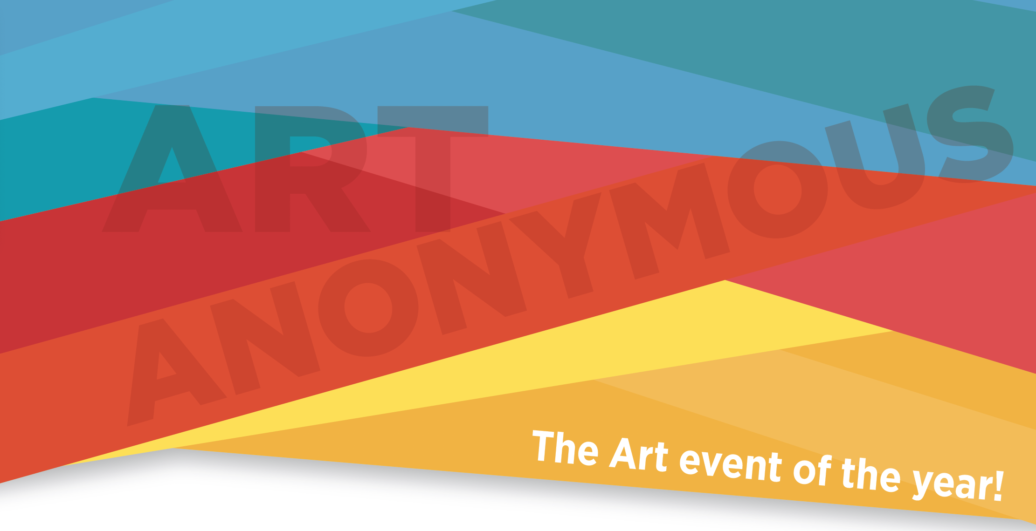

Presented by the Yukon Artist Relief Fund
7pm SATURDAY, Oct 19, 2024, THE OLD FIREHALL

What is Art Anonymous?

It is a fundraiser for the Yukon Artist Relief Fund.
The Yukon Artist Relief Fund offers short-term financial assistance to local artists facing health issues or personal tragedy. Do you know of an artist in need? Please share the word about YARF! Our website is www.yukonartistrelief.weebly.com.

It is an Evening of Art and Fun on Oct 19, 2024!
The event will showcase anonymous art pieces chosen by ticket holders through a drawing. Guests can choose between "Art & Fun" or "Just for Fun" tickets, enjoying wine, cheese, and entertainment while supporting artists in need.

Then, THE REVEAL!
After the tense excitement of drawing names and choosing art, the artists will be revealed!

All throughout the evening, there will be music, food, wine and more
Art Anonymous is a fun evening with great art entertainment of all kinds.

Questions? Email yukonartistrelief@gmail.com

Artists’ Art Guidelines

Thank you for creating art for artists! We warmly welcome all genres by the many great professional visual artists from the Yukon for our fundraiser. If you use a canvas, then the size is 1 foot x 1 foot. We offer free slim wood panels and slim canvases available at Yukon Artists @ Work. If you work with other media such as carving, sculpting, pottery, or others, we offer a $25 honorarium to assist with materials upon delivery of your art to YA@W. All 3D art must be a maximum size of about 1 cubic foot.

A selection panel will review the Anonymous Art
Please can we ask that your art be delivered to Yukon Artists @ Work by 6pm Tuesday Oct 1st. If your art is not chosen for our fundraiser, it will be returned. Please be sure to supply your address on the form provided.

The Important Details:
- Artist’s Signature: Only on the back or underneath, not visible from the front to maintain anonymity until the event.
- Title: Please place on the back or underneath the piece.
- Description: Provide a backstory for your artwork so that it’s new owner will have insight into your piece-see the form on the next page
- Biography: Complete the attached form to market yourself and your work.
- Style: No restrictions except for size (1’x1’ or about 1 cubic foot)
- Limit: We would be very thankful for a maximum of 2 pieces per artist to ensure diversity.
- Art Drop Off:
a. For canvas: Return in provided manila envelope; for 3D pieces, wrap well for anonymity.
b. Drop off at YA@W or mail to Art Anonymous c/o YA@W, 4129 4 Ave, Whitehorse, YT Y1A 1H7.
DEADLINE FOR ANONYMOUS ART:
6pm Tuesday Oct 1, 2024

And Let us Thank you with Free Lunch and Marketing!
We invite all contributing artists to a free luncheon at noon on the Saturday of the Art Anonymous Event. Not only will you be able to sip a beer or some wine, have some lunch and see the entire Art Anonymous Show, but professional photographer Mark Kelly has kindly offered to take head shots for your personal use. He will also be taking photos of all the art. These photos will be available to you and they will be featured on the Yukon Artist Relief Fund website and social media.
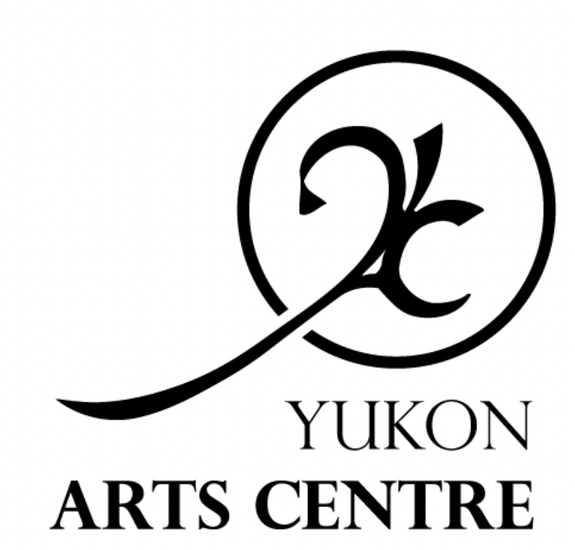
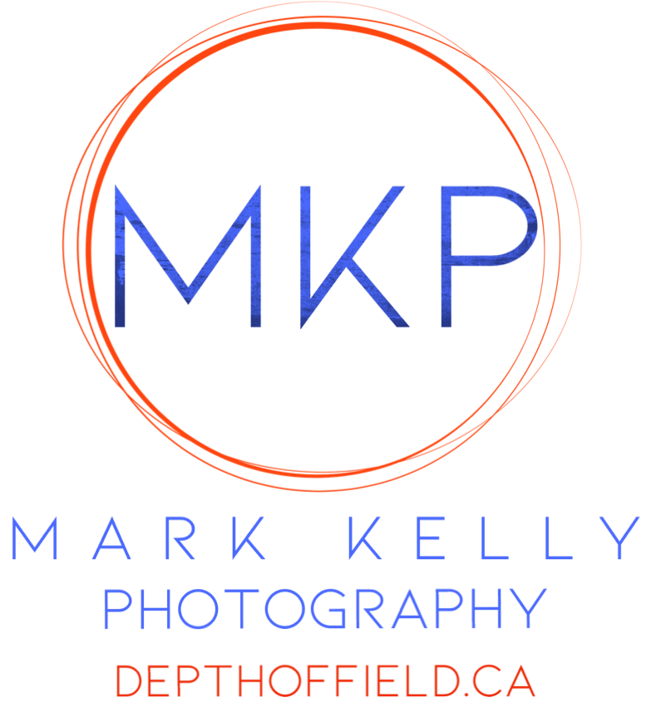
Huge thanks to our Sponsors:
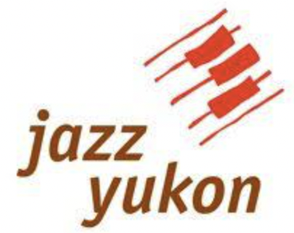

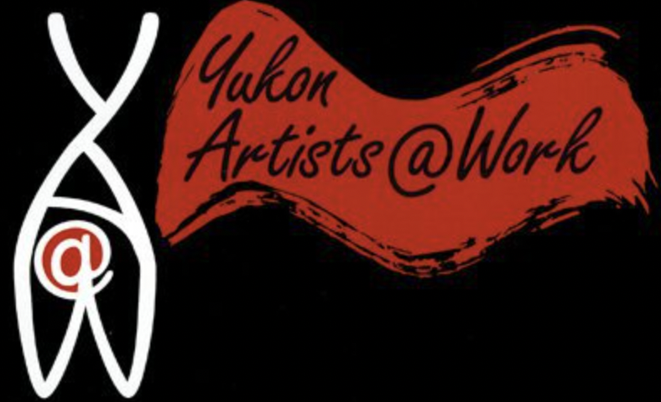
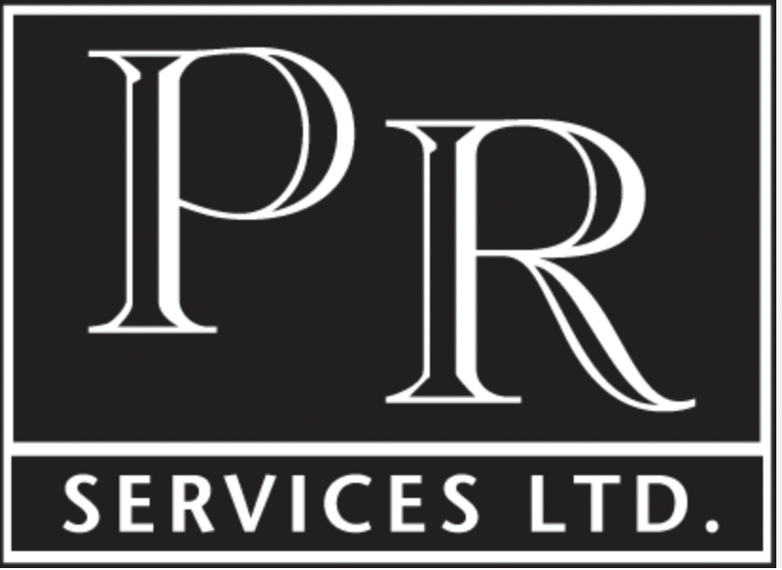
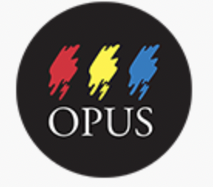

ART ANONYMOUS Information Form

Please deliver this form and your art to YA@W by Oct 1st

Name of Artist:_____________________________________________

Mailing Address: ___________________________________________

Email: ____________________________________________________
Your email and address will not be made available to anyone and will only be used for purposes of Art Anonymous and the Yukon Artist Relief Fund Society

About your work:
Title of piece:___________________________________________________________________

Description of the piece:
Include info that answers the following questions:
* What was your inspiration to create this work? *What media did you use? *Why did you choose these colours and shapes? *What other features of the work would you like to highlight? *Is your work about a certain location or event? *If so where or which one?

About you:
Tell us about your art education, whether self or formally taught, etc.

Where is your art available?

What contact information may we make public (address, e-mail address, telephone)?

Do you have a FB/Blog/Instagram/Website?

Anything else that you would like us to know and to include in our communications?

